SECTION JD

HAND OPERATED PRIMING PUMP

**CONTENTS**

Description .. Servicing

chapter

1

2

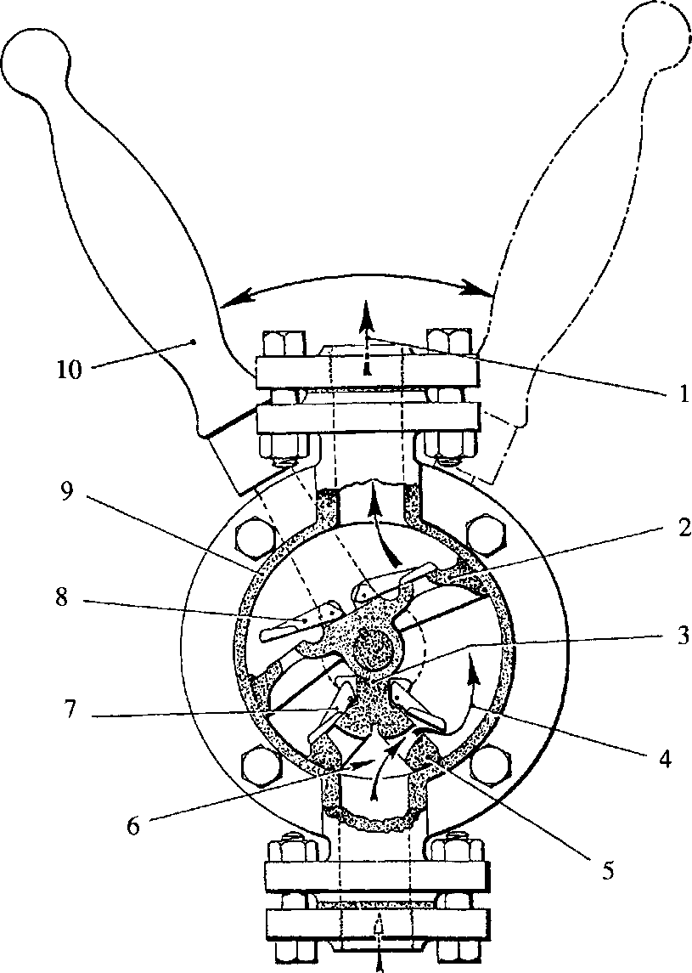

**CHAPTER 1**

**DESCRIPTION**

**SPD00344**

Key To Numbers

1. Delivery outlet 6.

Suction inlet Flap valve Flap valve Pump body Operating handle

1. Wing piston 7.
2. Packing strip 8.
3. Intermediate suction chamber 9.
4. Fixed carrier plate 10.

Fig JD.l Hand operated priming pump

1. The lubricating oil priming pump is a double-acting, semi-rotary, manually operated type incorporated in the lubricating oil circuit to enable oil to be supplied to all bearing surfaces before the engine is started.
2. The pump consists of an operating spindle carried in unbushed bearings and fitted with wing piston (2) which is a rubbing fit in body (9). The suction intake to the pump is divided by fixed carrier plate (5) which is sealed to the wing piston by packing strip (3). Gravity operated flap valves (7) and (8) fitted to the carrier plate and wing piston control the flow of oil.
3. The spindle is sealed where it passes through the front cover by an ’O’ ring. Operating handle (10) is secured to the spindle by a locknut.
4. The rocking movement of the handle first draws oil through flap valves (7) into intermediate suction chamber (4), the oil is then transferred through flap valves (8) in the wing piston to the delivery chamber on the return movement of the handle. On the next movement of the handle, the oil in the delivery chamber is forced through delivery outlet (1) by the oil passing through the wing piston from the suction chamber.

CHAPTER 2

SERVICING

Dismantling

1. Remove locknut and remove operating handle (10).
2. Release securing bolts and remove front cover.
3. Withdraw fixed carrier plate(s) and wing piston complete with spindle.

Inspection

1. Examine rubbing faces on wing piston and body for roughness.
2. Check that the flap valves on the wing piston and fixed carrier plate seat correctly and squarely and move freely. Ensure the seatings are free from dirt.
3. Examine the body and front cover sealing faces for burrs and indentations which may prevent a satisfactory seal. This is a metal to metal joint.

Assembly

1. Insert the operating spindle complete with wing piston and flap valves into the body bore.
2. Fit a new packing strip to the fixed carrier plate and fit to body. Check that the carrier plate is correctly engaged on its locating dowel and is fully bedded home into the body.
3. Fit a new 'O' ring seal to the spindle bore in the front cover, fit cover and tighten securing bolts.
4. Fit operating handle and securing nut.

NOTE The pump must be mounted in the vertical position.

SECTION JD

ALBANY MOTORISED PRIMING PUMP

CONTENTS

PRIMING PUMP

General

Removal and Dismantling .. Inspection

Assembly Testing and Fitting ELECTRIC MOTOR General Dismantling ..

Cleaning and Regreasing Reassembly and Commissioning

chapter

1

2

3

4

5

6

7

8

PRIMING PUMP - GENERAL

1. The Albany motorised lubricating oil pump is a unit construction electric double helical gear pump, fitted to prime the lubricating oil circuit. This ensures that oil pressure is available at the bearings before the engine is started.
2. The pump is capable of delivering 1400 gallons per hour at 1720 rpm and will allow the engine to start within seconds after the priming circuit is activated. The pressure relief valve is preset at 2.07 bar and should normally not require further adjustment.
3. Direction of Rotation - Priming pumps may be run in either direction, so care should be taken to ensure that the correct motor polarity for right hand rotation is observed on initial installation or after overhaul, ie. rotation is anti-clockwise looking on the pump end. Also ensure that the relief valve assembly is correctly fitted on the left hand or delivery side of the pump.
4. Relief Valve - Is incorporated in the pump body and pre-set before despatch for release at 2.07 bar (30 lb/in2). Should any further adjustment be necessary, slacken adjustment screw locknut (21)(Fig JD.3) and either, screw adjustment screw (20) in to increase pressure or out to decrease pressure. Only minimum adjustment is required. Domed nut (29) is fitted to the adjustment screw for secondary locking and for protection of the adjusting screw threads.
5. A bleed hole drilled in the bottom of the pump front cover (which connects the pump body to the motor) allows leaking oil to drain if the rotary mechanical seal fails. In the event of seal failure the pump should be stopped and the mechanical seal replaced or the unit returned for overhaul.

REMOVAL AND DISMANTLING

1. Disconnect pipes to the lubricating oil pump.
2. Isolate and disconnect electrical supply to motor, remove complete unit from its mounting and place on a suitable workbench.
3. Release and remove motor fan guard (30)(Fig JD.3) to provide access to the motor shaft and enable the unit to be held against rotation.
4. Using a suitable alien key, remove the eight 1/4 in UNC capscrews (15), attaching back cover (2) to body (4). Separate the back cover from the body and dowels (27), by using suitable jacking screws in the two 1/4 in tapped holes in the cover. Discard old gasket (3).
5. Using the same alien key, remove the eight 1/4 in UNC capscrews (18) with spring washers attaching body (4) to front cover (11). Using jacking screws in the two 1/4 in tapped holes remove body (4), withdraw idler shaft (17) from front cover (11) and remove idler rotor (16).
6. Remove driving rotor (32), which is a sliding fit on the motor driving shaft (1), key
7. and insert (6) from driving shaft (1). Release grubscrew (8) in collar (7), and remove the collar from the driving shaft.
8. Carefully remove rotating section of mechanical seal (9) from driving shaft (1). To replace mechanical seal seat (31), remove the four 8mm capscrews (10), and remove front cover (11). Using a suitable piece of tube, push out the seal seat. If not replacing seal, store the mechanical seal to prevent accidental damaged.
9. To remove relief valve assembly, remove domed nut (29), release locking nut (21), and remove adjusting screw (20), washer (22), spring (23), and seat (24).

CHAPTER 3

INSPECTION

1. Due to its intermittent use, the life of the priming pump would normally be expected to exceed that of the engine, apart from occasional replacement of leaking rotary mechanical seals (9). The following text is therefore only a guide to checking for replacement of component parts should this be required.
2. Check both sections of mechanical seal for damage or wear paying particular attention to the rubbing faces. Renew seal assembly if damaged or worn.
3. Check rotors for wear, ridging, scuffing, or pitting. If worn renew as a matched pair.
   1. Check body for internal wear, scuffing or pickup. Renew if worn or badly scored in the bores.
   2. Check bushes for wear. Renew as a set if worn
   3. Check collar and grubscrew threads for serviceability.
   4. Check idler shaft for wear. Renew if worn.
   5. Check motor shaft for wear. Renew if worn.
   6. Check insert for wear. Renew if damaged or worn.
   7. Check relief valve spring condition, and length. Check condition of the relief valve and body seat.

ASSEMBLY AND FITTING

NOTE All joints and 'O' rings must be fitted dry.

1. The following text is based on the assumption that the pump has been completely dismantled for overhaul.
2. Press new bushes (13) and (14)(Fig JD.3), into front and rear covers (11) and (2). Bushes (14), should be flush with the surface of the covers when fitted.
3. Push mechanical seal seat (31) into position in front cover (11). Ensure that seal seat sits squarely in the cover, any distortion may cause the seal to leak.
4. Using the four 8mm capscrews (10) carefully fit and secure front cover (11) to electric motor (12)
5. Fit rotating section of mechanical seal (9) onto motor shaft (1). Using a straight edge to keep it flush with the face of front cover, fit collar (7) to shaft (1) and secure with grubscrew (8).
6. Fit insert (6) to front cover (11).
7. Fit key (5) to motor shaft (1), lubricate driving rotor (32) and slide onto shaft (1) and key (5).
8. Fit relief valve (24), spring (23), and adjusting screw (20) to pump body (4). Fit locknut (21) with fibre washer (22) to adjusting screw (20).
9. Lubricate idler shaft (17), and idler rotor (16) and fit to front cover (11).
10. Place a new gasket (3) in position over the dowels in front cover (11). Slide pump body (4) over driving and idler rotors (32) and (16) to engage with the dowels in the front cover, and secure using eight capscrews (18) and spring washers.
11. Fit a second gasket (3) to the rear cover side of pump body (4), lubricate bushes and slide rear cover (2) onto motor and idler shafts and into engagement with the two dowels. Secure using eight capscrews (15). Tighten capscrews evenly while rotating the motor fan to check for free rotation of the pump.
12. Refit and secure motor fan guard (30).
13. Attach unit to a suitable test rig, prime the pump with lubricating oil, run to test and set relief valve pressure (Chapter 1). Refit domed nut (29).
14. Fit complete unit to its mounting, and reconnect electrical supply and lubricating oil pipework.

ELECTRIC MOTOR - GENERAL

1. The motor is continuously rated at 440 volt, 3 phase, 60 hertz.
2. The motor should be kept as clean as possible. See that the cowl intake vents are not obstructed. This would restrict the flow of cooling air to the motor and cause overheating.
3. Ensure that the motor runs smoothly.
4. Check the security of all electrical connections with the motor isolated from the supply. Check that holding down bolts are secure.

Lubrication

1. Bearings are correctly packed with grease on assembly, which is sufficient for at least two years continuous operation without attention under normal conditions.
2. Refer to Chapter 7 for details of regreasing and bearing checks.

CHAPTER 6

DISMANTLING

* 1. Cage induction motors are simple in construction but care should be exercised when dismantling or reassembling the motor. Damage can be caused to the windings, bearings, shaft and rotor if handled indifferently.

Dismantling (Figs JD.l and JD.2)

* 1. Remove priming pump (Chapter 2).
  2. Unscrew drive end endshield fixing screws and tap off endshield using a wooden drift. Care should be taken to avoid damaging any shaft seals which may be fitted.
  3. Remove fan housing.
  4. Knock out fan fixing pin (where fitted) and ease fan off rotor shaft, by pulling and twisting slightly.
  5. Rotors are located by means of bearing retaining clamps (tab nuts) at the non-drive end (Fig JD.2). To remove the endshield from the frame it is only necessary to rotate the screws anti-clockwise by approximately 1.5 turns to operate the release mechanism. Unscrew the endshield fixing screws, and the endshield can then be tapped off the frame spigot.
  6. The rotor can now be withdrawn from the stator.
  7. Remove bearings using drawing off gear, applying pressure to the inner race only. Remove non drive end shield.

CLEANING AND DEGREASING

1. When carrying out a complete overhaul, wash out bearings in a good quality grease solvent, cleaning out all traces of old grease and contamination from the bearings and end shields. After washing, dry the bearings and dip in a good quality light machine oil. Check bearings for running clearance by feel. If excessive replace with new bearings.

CAUTION OBSERVE THE RELEVANT SAFETY PRECAUTIONS WHEN USING SOLVENTS.

Recommended Grades of Grease

Standard grease Shell Alvania RA

Equivalent greases of other manufacture BP Energrease LS3

Castrol Spheerol AP3

Esso Beacon 3

Gulf Gulfcrown No 2

Mobil Mobilplex 48

Regent Regal Starfak Premium 3

Grease fill quantities for bearings and endshields (cm3)

Drive end Non drive end

Bearing Endshield Bearing Endshield

6.0 10.0 6.0 8.0

1. Re greasing of cleaned or new bearings should be in accordance with the data given above, the indicated quantities being inserted in the 'OPEN' side of the bearing and into the motor endshield respectively. Ensure that the regreasing operation takes place under clean conditions.
2. Any dirt accumulated in the endshields, frame or stator windings should be cleaned out by blowing with compressed air, making sure that the terminal box is also free of any contaminate. If compressed air is not available, bristle brushes and cloths may be used. DO NOT use wire brushes or scrape windings or leads. To remove greasy deposits or oil use a cloth moistened with white spirit or similar solvent. These solvents are inflammable and the usual care with regard to naked flames must be observed.

REASSEMBLY AND COMMISSIONING

NOTE All joints and 'O' rings must be fitted dry.

1. Reassembly is the reverse of the dismantling procedure, taking care that the tab nuts are in the off position when fitting the non-drive end endshield, and that the fan and fan housing are assembled correctly.
2. The shaft seals should be examined and any defective seals replaced. Additional sealant may also have been applied during motor manufacture (eg. at the endshield/frame joint face) to give the degree of protection quoted on the motor rating plate. If there is any doubt as to where sealant should be applied to restore the motor to its originally protected condition, please consult the works.
3. All fixing screws should be tightened evenly, making certain that no distortion of endshields occurs.
4. Rotate shaft. If locked or stiff, loosen the endshield screws and re-tighten, spinning the shaft to ensure freedom.
5. Before running, check that fan does not foul the housing. Any offending dents should be removed by knocking out the damaged areas of the housing.

Commissioning

1. Treat as a new machine, checking that the motor rating plate is secured on the frame and that the fan cowl is in the correct position.
2. Ensure that cabling and unions are correct and secure before switching on the motor to check rotation. Switch off and rebuild the priming pump to the motor.

Spares

1. When ordering spares please supply the following details, which appear on the machine rating plate:

Serial number kW

Frame size rev/min

as well as a description of the item required.

Installation Safety Check List

1. Ensure satisfactory earth system of motor and controller. Installation must be approved by a qualified person.
2. Ensure supply details correspond with motor rating plate details.
3. Ensure motor is free to rotate and has not been damaged during transport or installation.

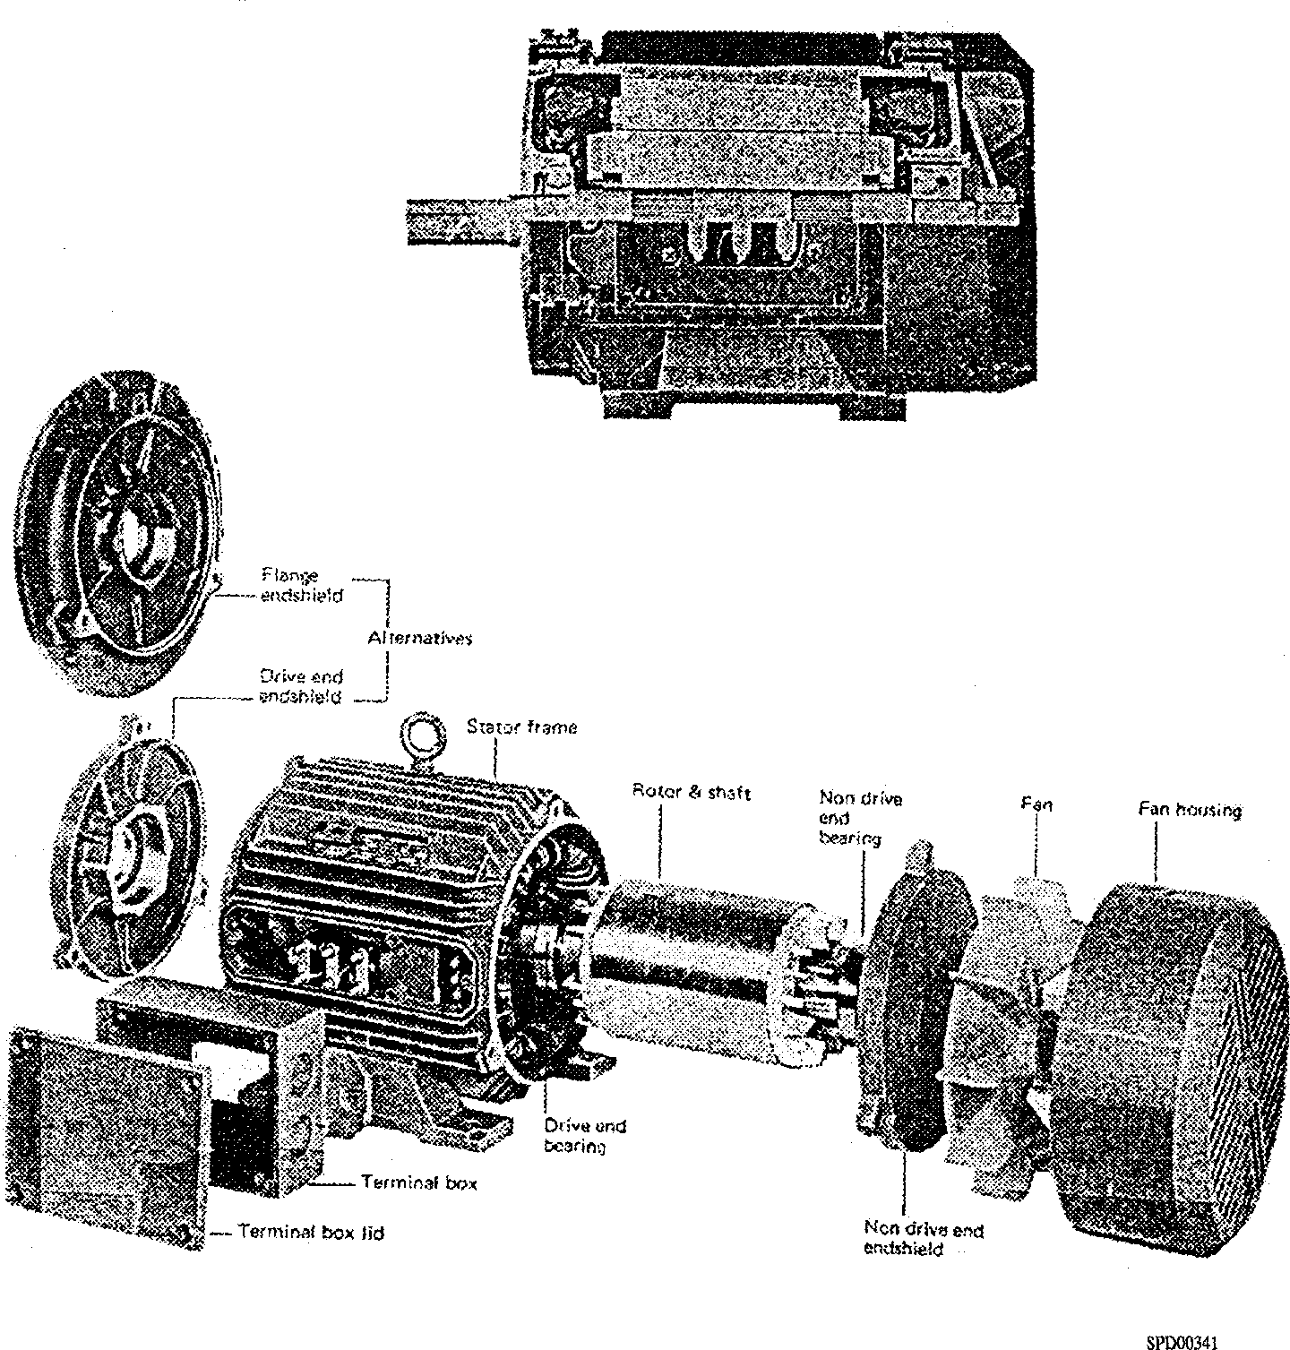

**Fig JD.l Sectional and exploded views of typical motor**

Crimped screw Spring

limits axial washer

movement of retention device

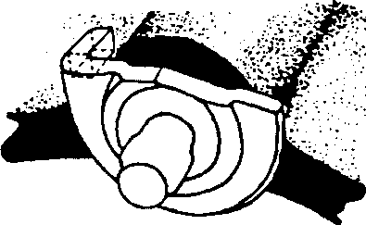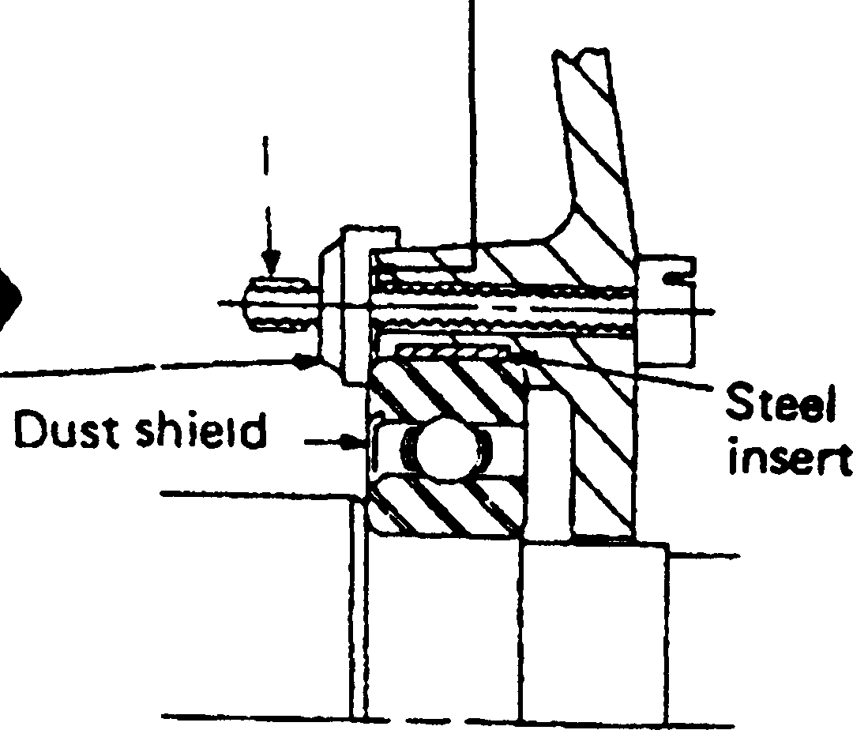Open

Closed

position

/^Patented

'; ■ bearing'tftention \ -device

position

View at arrow showing retention device in closed and open spdoo342

positions

Fig JD.2 Detail of non-drive end bearing arrangement showing retaining clamps

Key To Numbers

|  |  |
| --- | --- |
| 1. | Motor shaft |
| 2. | Back cover - pump |
| 3. | Gasket |
| 4. | Body - pump |
| 5. | Key |
| 6. | Insert |
| 7. | Collar |
| 8. | Grubscrew |
| 9. | Rotary section - Mechanical seal |
| 10. | Capscrew |
| 11. | Front cover - pump |
| 12. | Electric motor |
| 13. | Bush inner |
| 14. | Bush outer |
| 15. | Capscrew |
| 16. | Idler rotor |

1. Idler shaft
2. Capscrew
3. Spring washer
4. Adjusting screw
5. Locknut
6. Fibre washer
7. Spring
8. Relief valve seat
9. Plug
10. Plug
11. Dowel
12. Tapped withdrawal hole
13. Dome nut
14. Fan guard
15. Seat section - Mechanical seal
16. Driving rotor

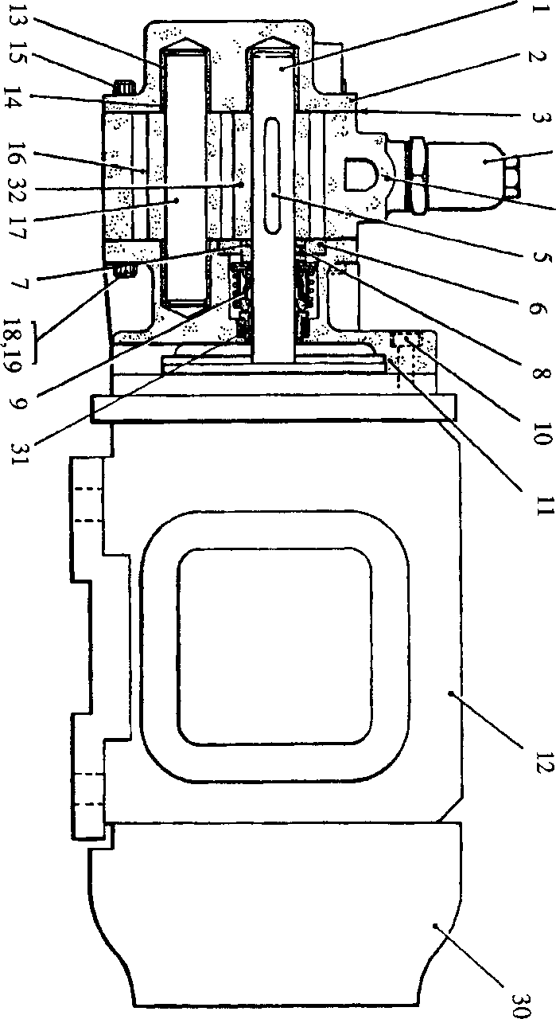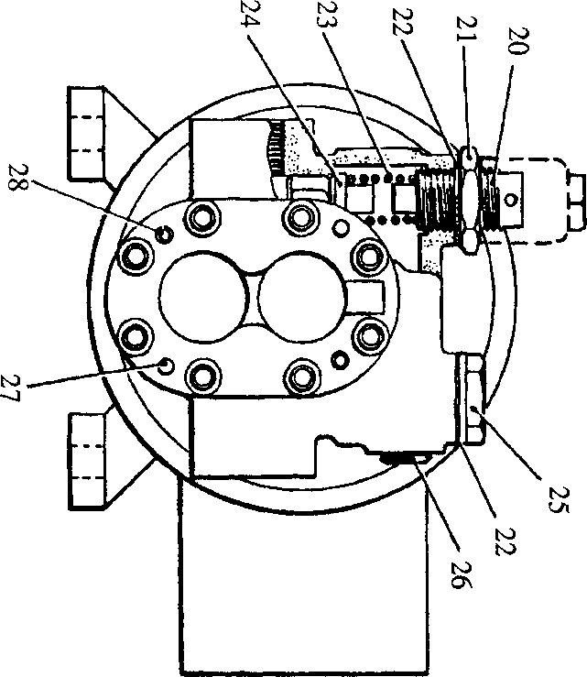

**SPD00340**

Fig JD.3 Motorised lubricating oil priming pump